Sponsor a Kalamazoo-Based Amateur Cycling Team

About the team
The Kalamazoo Bicycle Club (www.kalamazoobicycleclub.org) is forming an amateur bicycle racing team dedicated to promoting the benefits of recreational and competitive cycling. The team consists of about fifteen cyclists who will train together all season and participate in regional bicycle races. The team needs funds to offset some of the expenses of running a racing program. We are offering sponsorship opportunities to Kalamazoo-area businesses that would like to take advantage of this exciting opportunity.

Why sponsor a cycling team?
- Cycling is a wonderful sport that can be enjoyed by all ages.
- Cycling has a great image. Cyclists are viewed as a model of peak physical shape and performance.
- We intend to align the team with a local charity event, bringing awareness to the charity and exposure to cycling.
- The sport has enjoyed a greater audience with the recent successes of U.S. athletes: Lance Armstrong (6-time Tour de France winner), Tyler Hamilton (Olympic gold), Bobby Julich (Olympic bronze) and Dede Barry (Olympic silver).
- Team members wear jerseys with your company logo all year while training and racing.
- Thousands of people will see these jerseys on the road while the team is training; hundreds of other cyclists and race fans will see it up-close at races and other group rides.
- The team will work with your company to offer primes (prizes awarded to the winner of a designated lap) at regional races…an excellent way to associate your organization with the excitement of a sprint to the line.
- Your company name will be seen supporting the local community.
- You have the option of continuing the commitment to next year’s team as well.

Sponsorship levels
#1 Title Sponsor | $2000 | #4 Silver Sponsor | $500
#2 Gold Sponsor | $1000 | #5 Bronze Sponsors | $200
#3 Silver Sponsor | $500
Other sponsorship arrangements are negotiable. See overleaf for approximate physical layout of jersey.

What is provided to sponsors
- Your company name and logo appear on the team jerseys.
- Links on the team’s web site to your company.
- Opportunity to offer primes at regional races.
- Complimentary jersey provided at or above the $500 sponsorship level.

What we need
- The team can accept your sponsorship in the form of a check made out to Kalamazoo Bicycle Club Race Team.
- We will need high quality line art of your company logo to transfer to team jerseys.
- Keep in contact with your team representative if you are interested in race prime promotion opportunities.

Contact team manager
David C. Sperry | 425 Brittany Dr., Portage, MI 49024
Home: 269-324-7998| Work: 269-833-9032 | dcsperry@yahoo.com

Regional Racing Calendar
Race | Location | Race | Location
Grattan Race series | Belding, MI | The Great Race Criterium | South Bend, IN
Tippicanoe River State Park RR | Tippicanoe River State Park, IN | The Great Race Road Race | South Bend, IN
Tippicanoe River State Park TT | Tippicanoe River State Park, IN | Tour of Cedar Creek | Twin Lake, MI
Layfayette Road Race | Layfayette, IN | Major Taylor Road Race | Grand Blanc, MI
Tour of South East MI, TT | Monoe, MI | Rose City Criterium | Jackson, MI
Tour of South East MI, RR | Milan, MI | Ada Criterium | Ada, MI
Kensington Road Race | Kensington Metro Park, MI | Rockford Classic Criterium | Rockford, MI

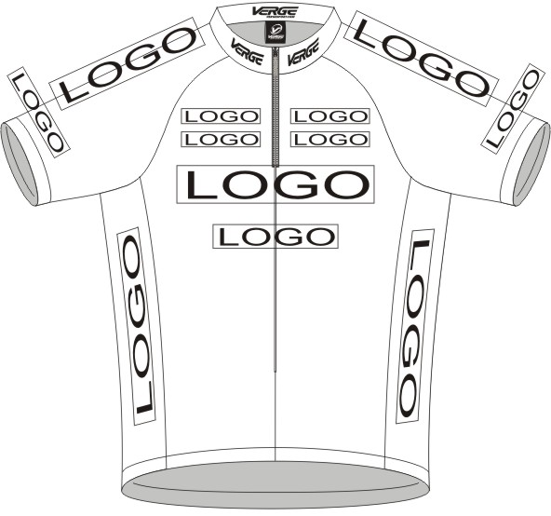
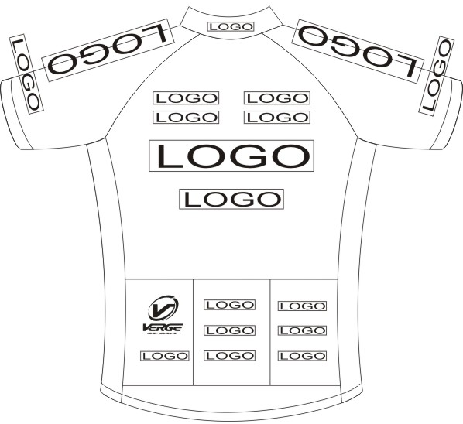
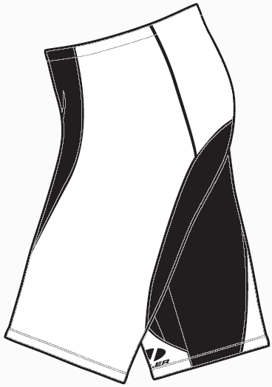
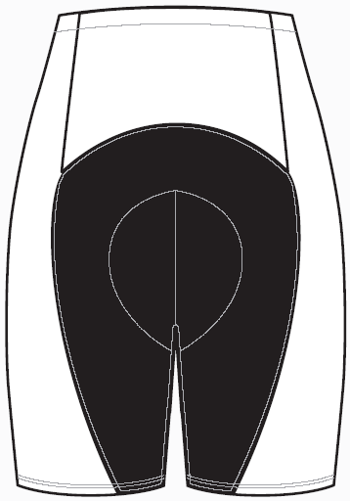
#1 Title Sponsor
$2000
Top-Center Front and Back on Jersey and Center-Back of Shorts

#2 Gold Sponsor
$1000
Sides of Jersey and Shorts
#3 Silver Sponsor
$500
Top of shoulders on Jersey
#4 Silver Sponsor
$500
Low –Center Front and Back of Jersey
#5 Bronze Sponsors
$200
Pockets on Back of Jersey

